**Ability to Import Data in Power BI**

KO 1: Able to Connect to Databases, Data Warehouses, SSAS Cubes, and Power BI Data Models Using Power BI

Structured Data Sources

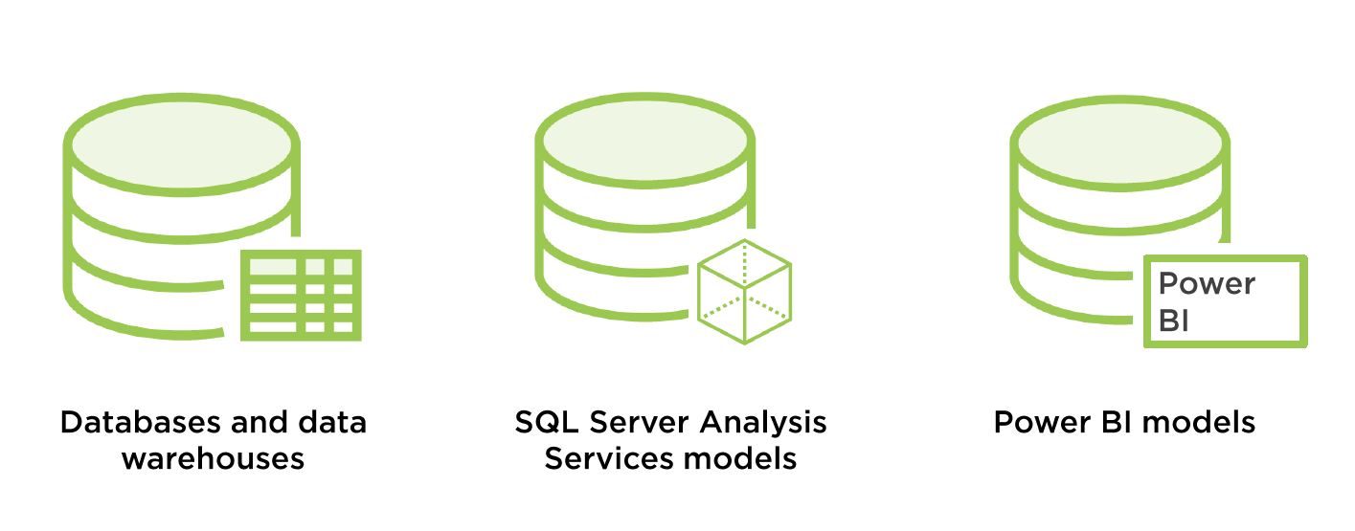

**Connecting to AzureSqlDatabases:**

Step 1: go to **Get data.**

Step 2: go to **Azure** and select **Azure Sql database**.

Step 3: click on **Connect**.

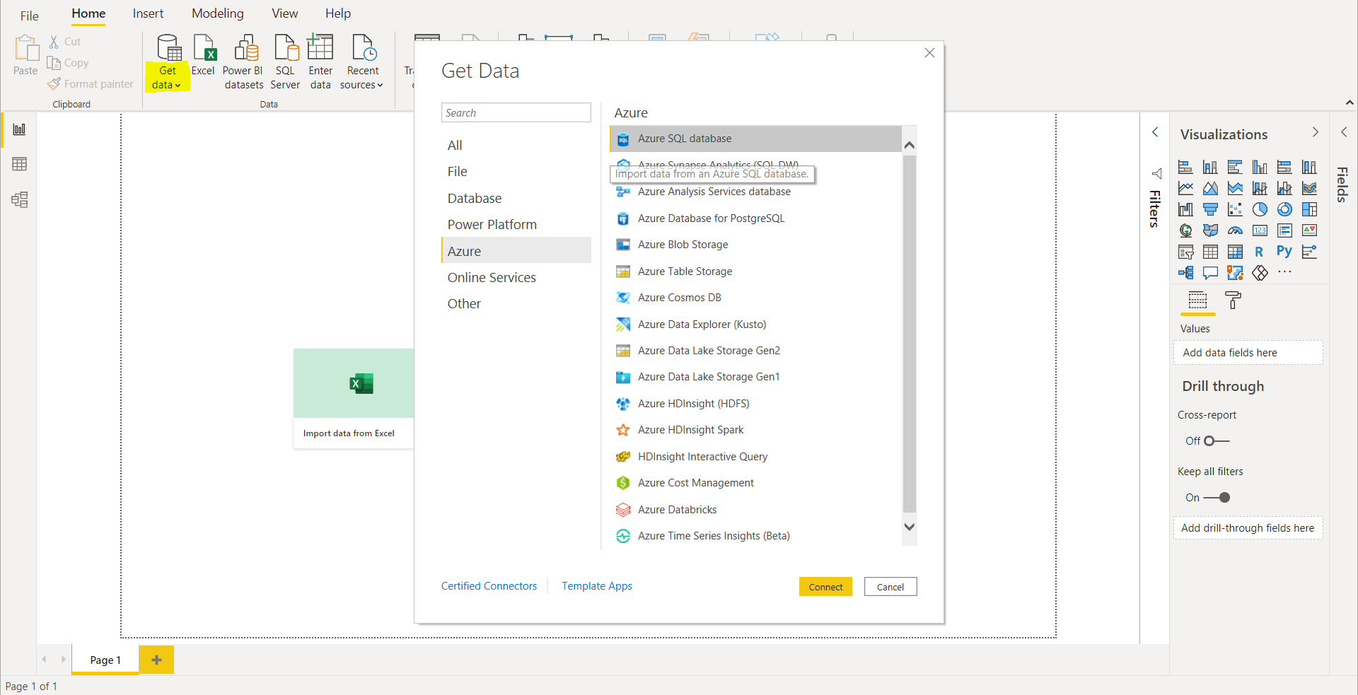

Now you will be asked to Authenticate to your database,

Step 4: Enter the **Server name** and **database** name of the Azure Database

Step 5: Select **Import** (Importing data directly into Power BI without writing any queries).

Step 5: Click on **OK**

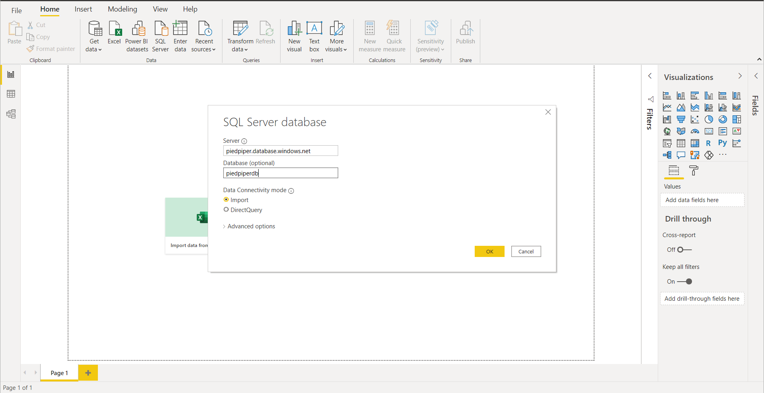

Now, we can see the Navigator page, then Expand database where you can see all the Tables.

Step 6: select **Sales.T.Product** and **Sales.T.ProductCatogory** Tables to load.

Step 7: Click on **Load**.

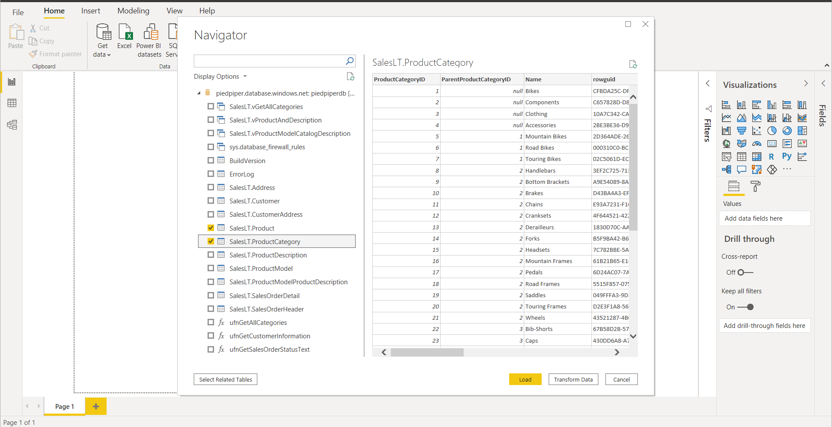

You can see that the tables loaded successfully.

Step 8: Select **stacked column chart** in **visualizations.**

Step 9: select **StandardCost** and **ProductCategory** in fields section to check the Report.

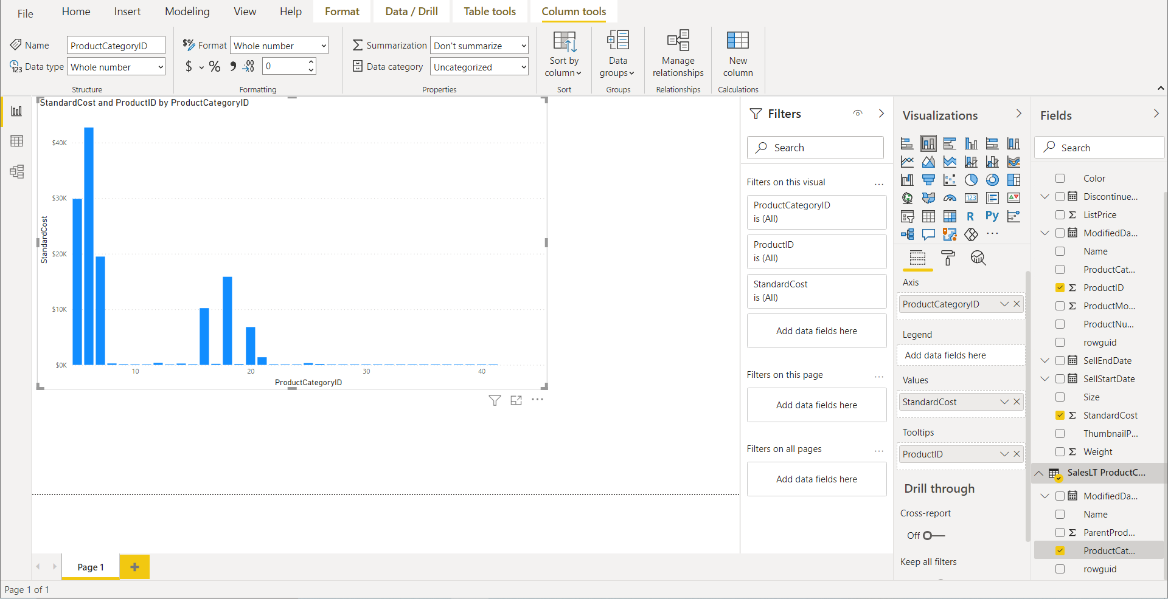

To Connect to **Data Warehouses**:

Step 1: go to **Get data.**

Step 2: go to **Azure** and select **Azure Synapse Analytics(SQL DW)**.

Step 3: click on **Connect**.

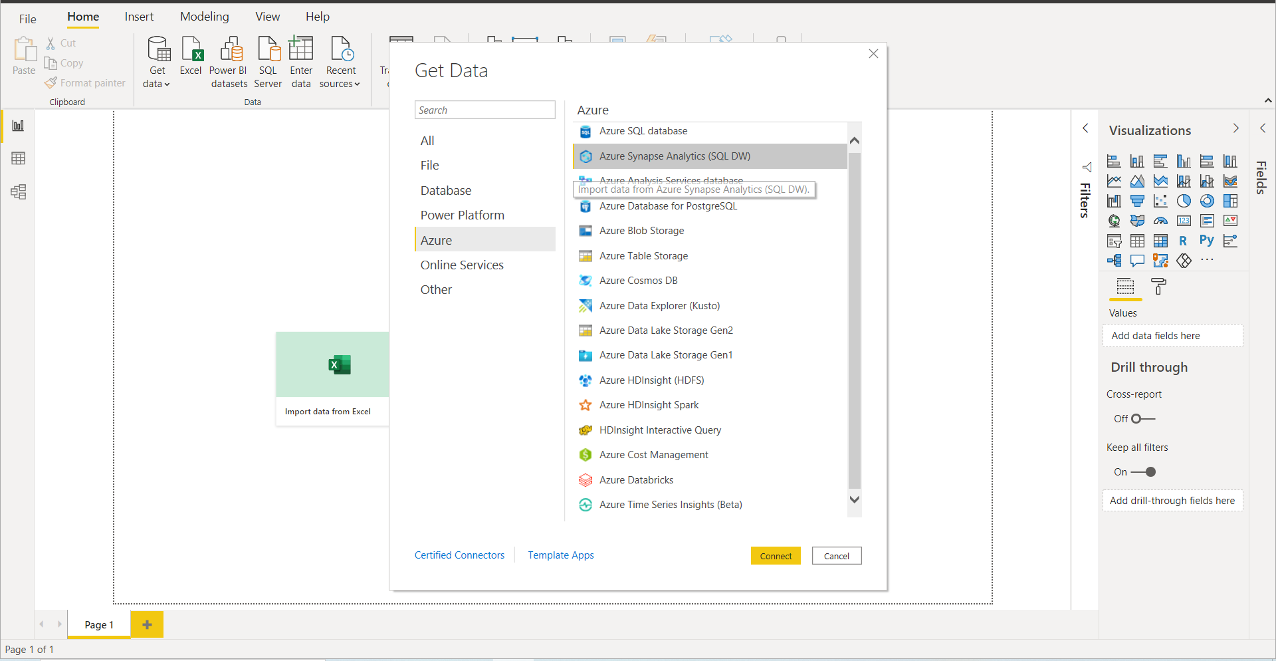

Step 4: Enter the **SqlServer** and **database** name of AzureSynapseAnalytics

Step 5: Select **Import**

Step 5: Click on **OK**.

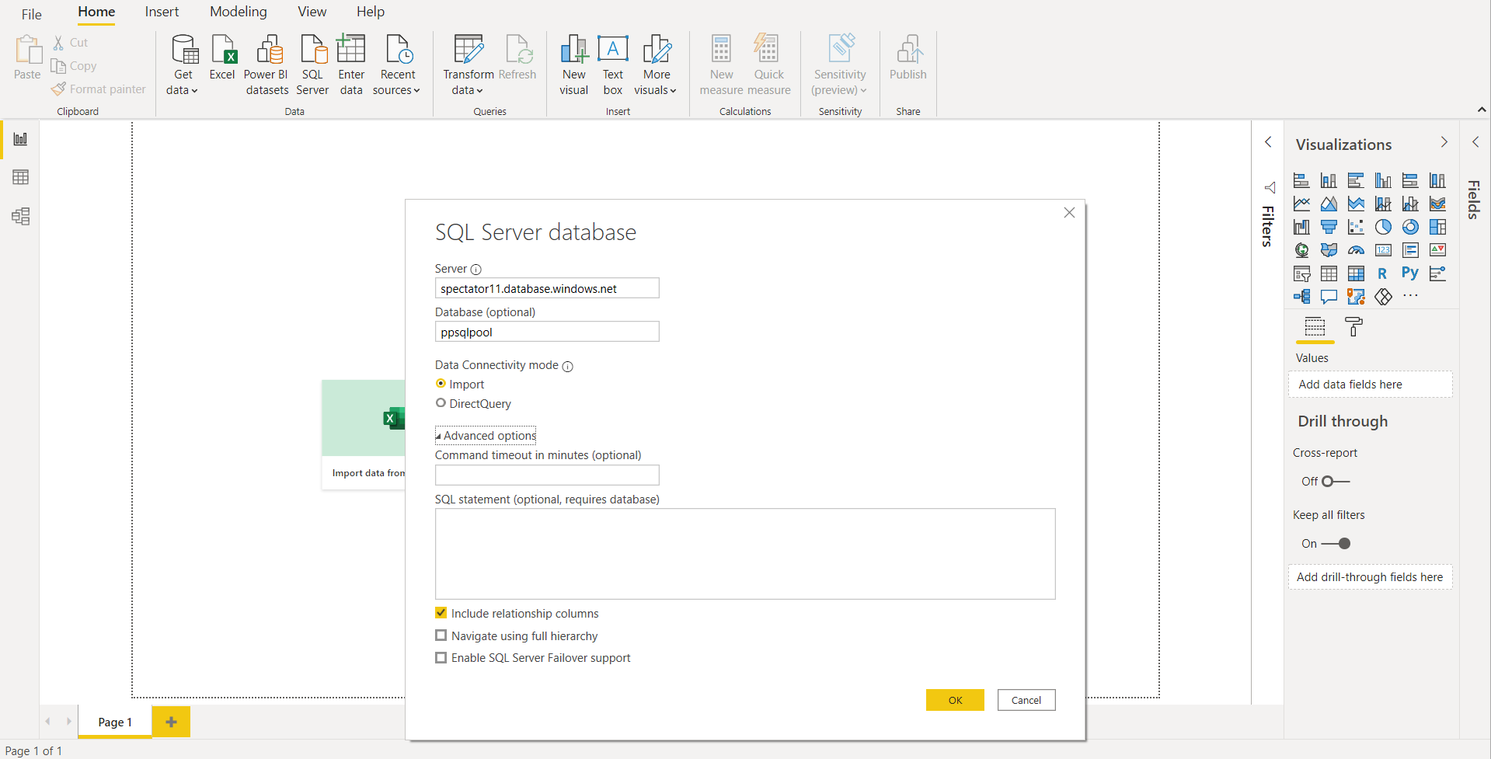

Now, we can see the Navigator page

Step 6: select **Dim.DepartmentGroup** and **Dim.Employee** Tables to load.

Step 7: Click on **Load. OR** to perform any Transformations Click on Tansform Data

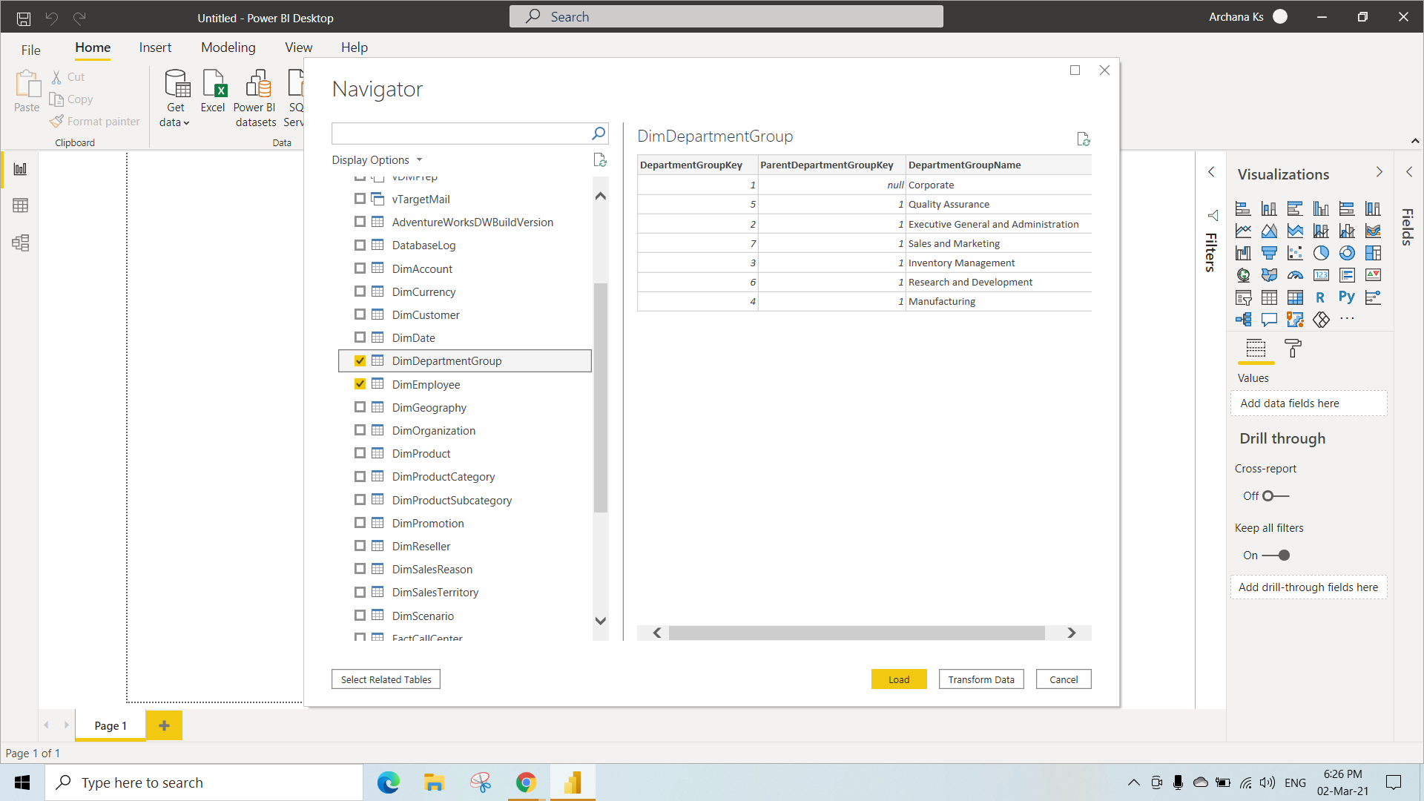

Step 8: Select **stacked coloum chart** in **visualizations.**

Step 9: select **DepartmentGroupName** and **EmployeeCount** in fields section to check the **Report**.

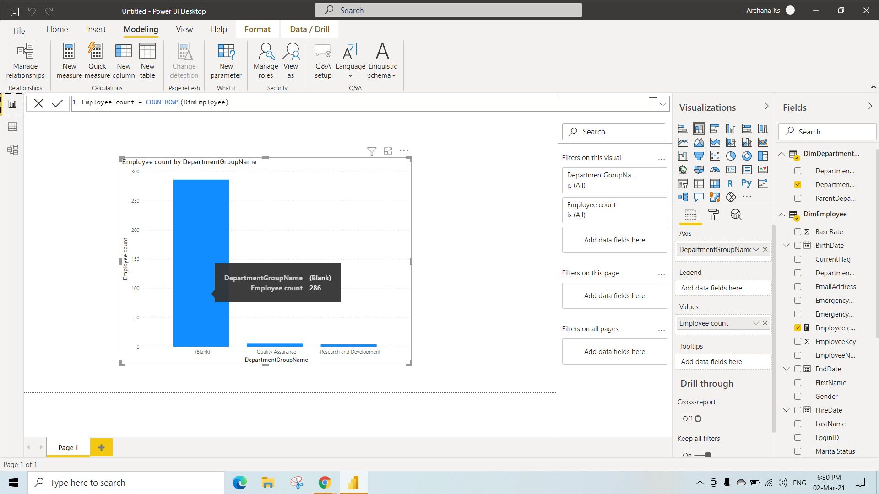

To Connect to **SSAS Cubes**:

Initially Create a **Analysis Services** account in Microsoft Azure.

Step 1: Search for **Analysis Services** click on **Create.**

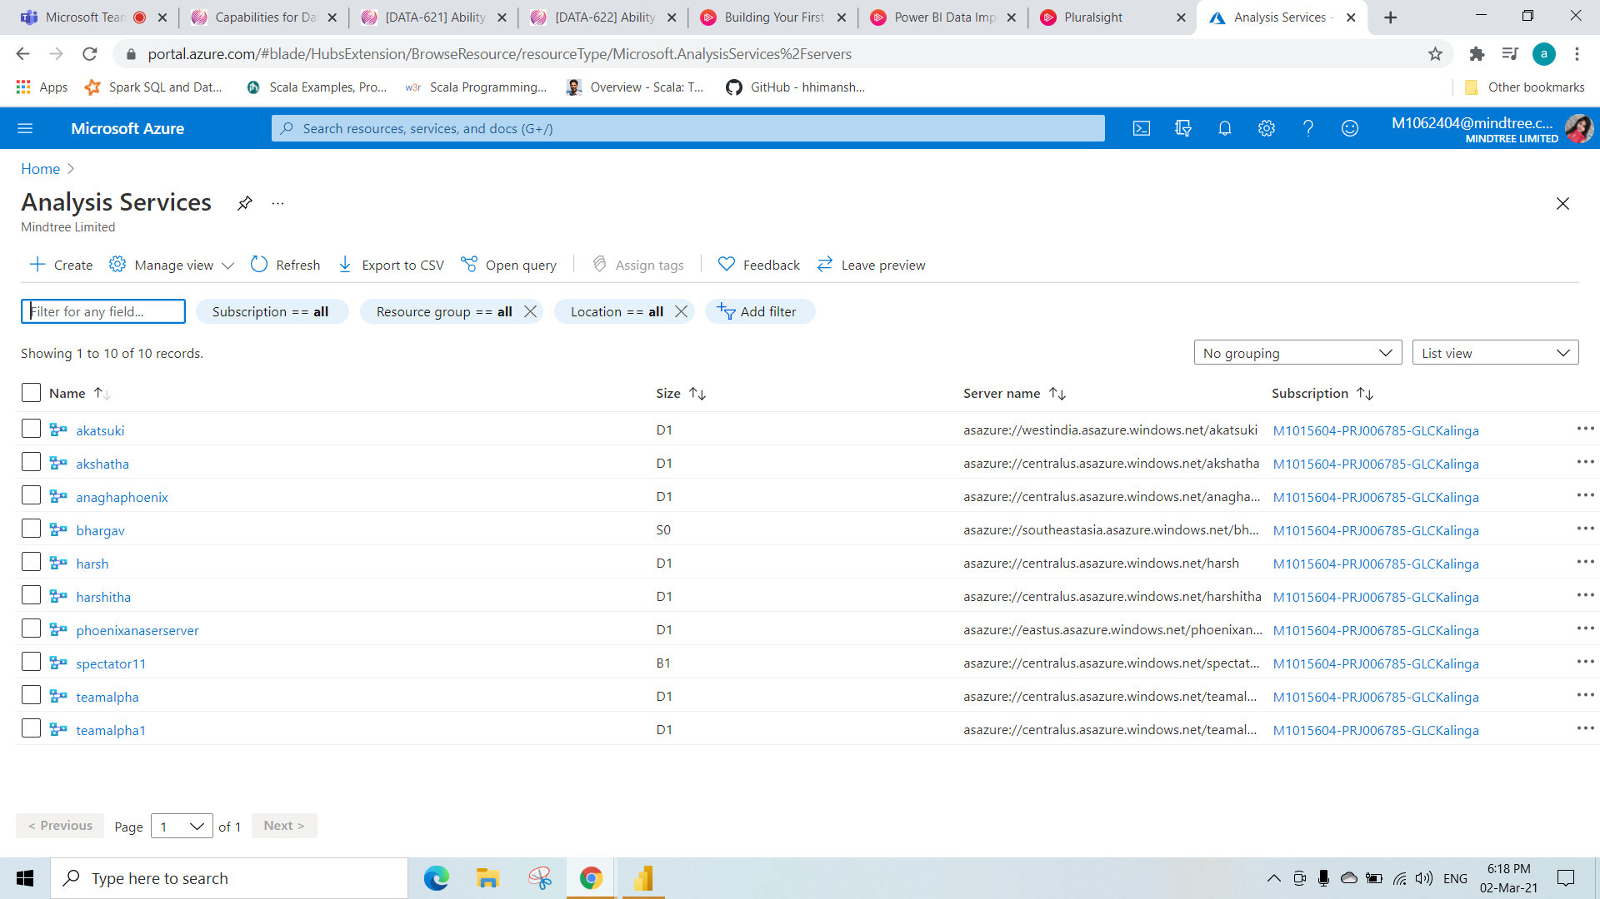

Step 2: Fill all the details as shown in the picture.

Enter the Server Name

Select the Subscription

Select the Resource Group

Select the Location

Select Pricing Tier as B1

Step 3: click on **Create**.

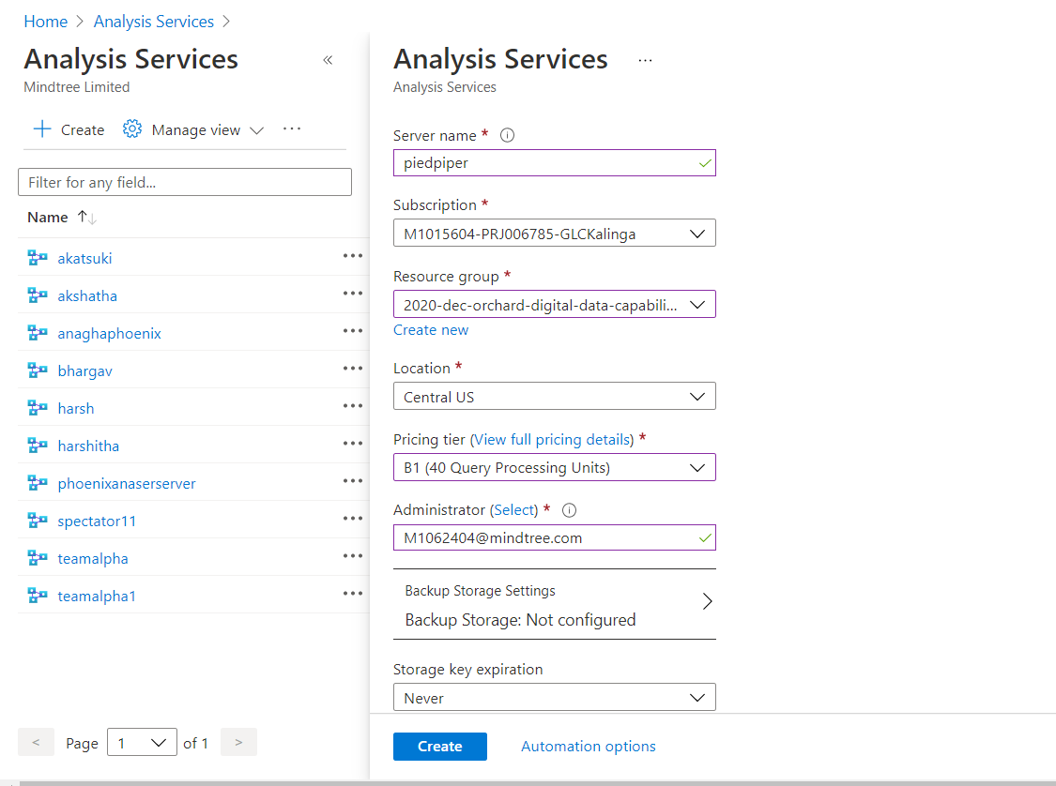

Home page (Analysis services) in Microsoft Azure

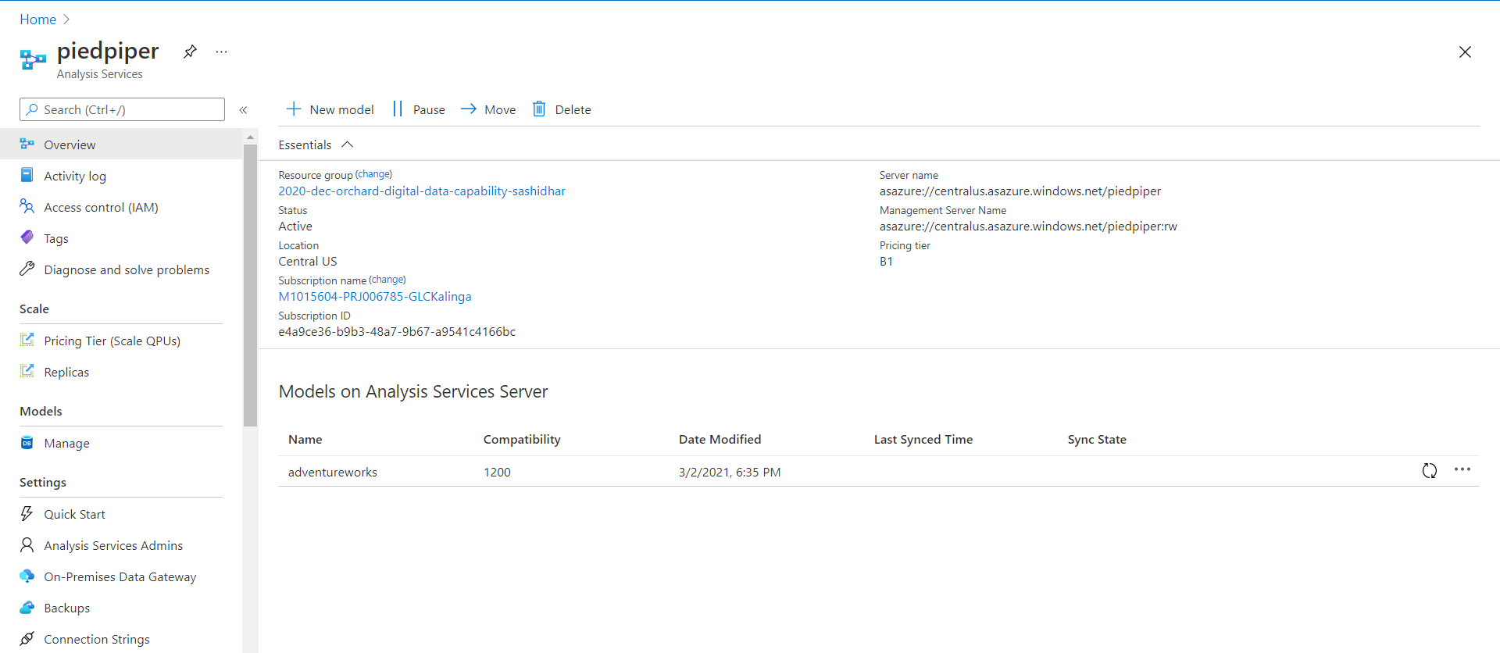

Step 1: go to **Get data.**

Step 2: go to **Azure** and select **Azure Analysis Services database.**

Step 3: click on **Connect**.

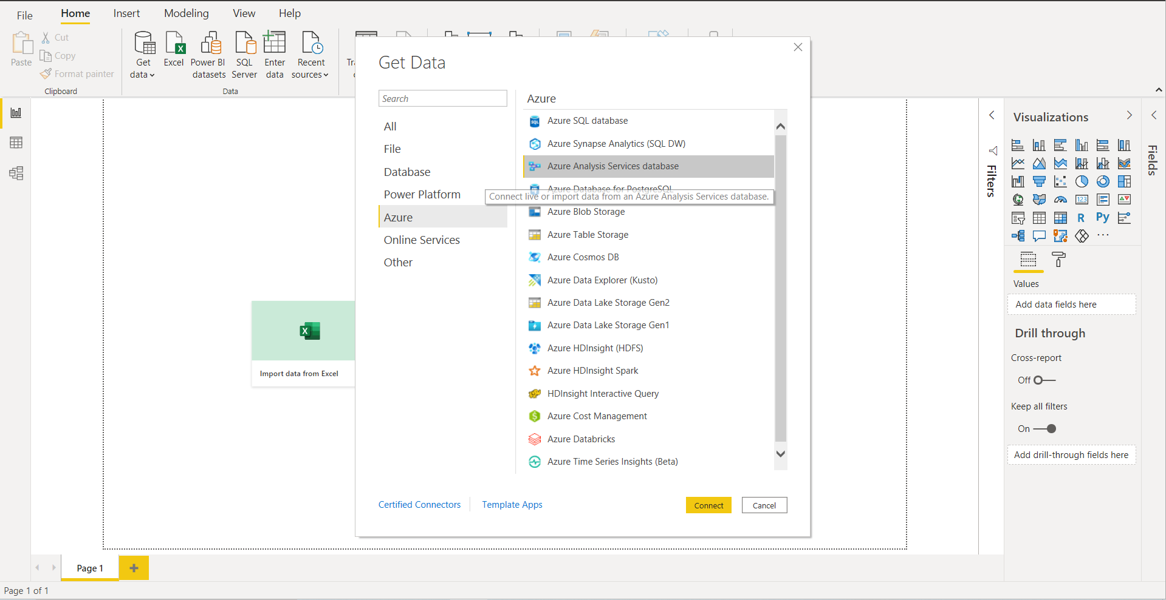

Now you will be asked to Authenticate to your database,

Step 4: Enter the **Server** and **database** name as adventureworks from the Microsoft Azure

Step 5: Select **Connect live**.

Step 5: Click on **OK**.

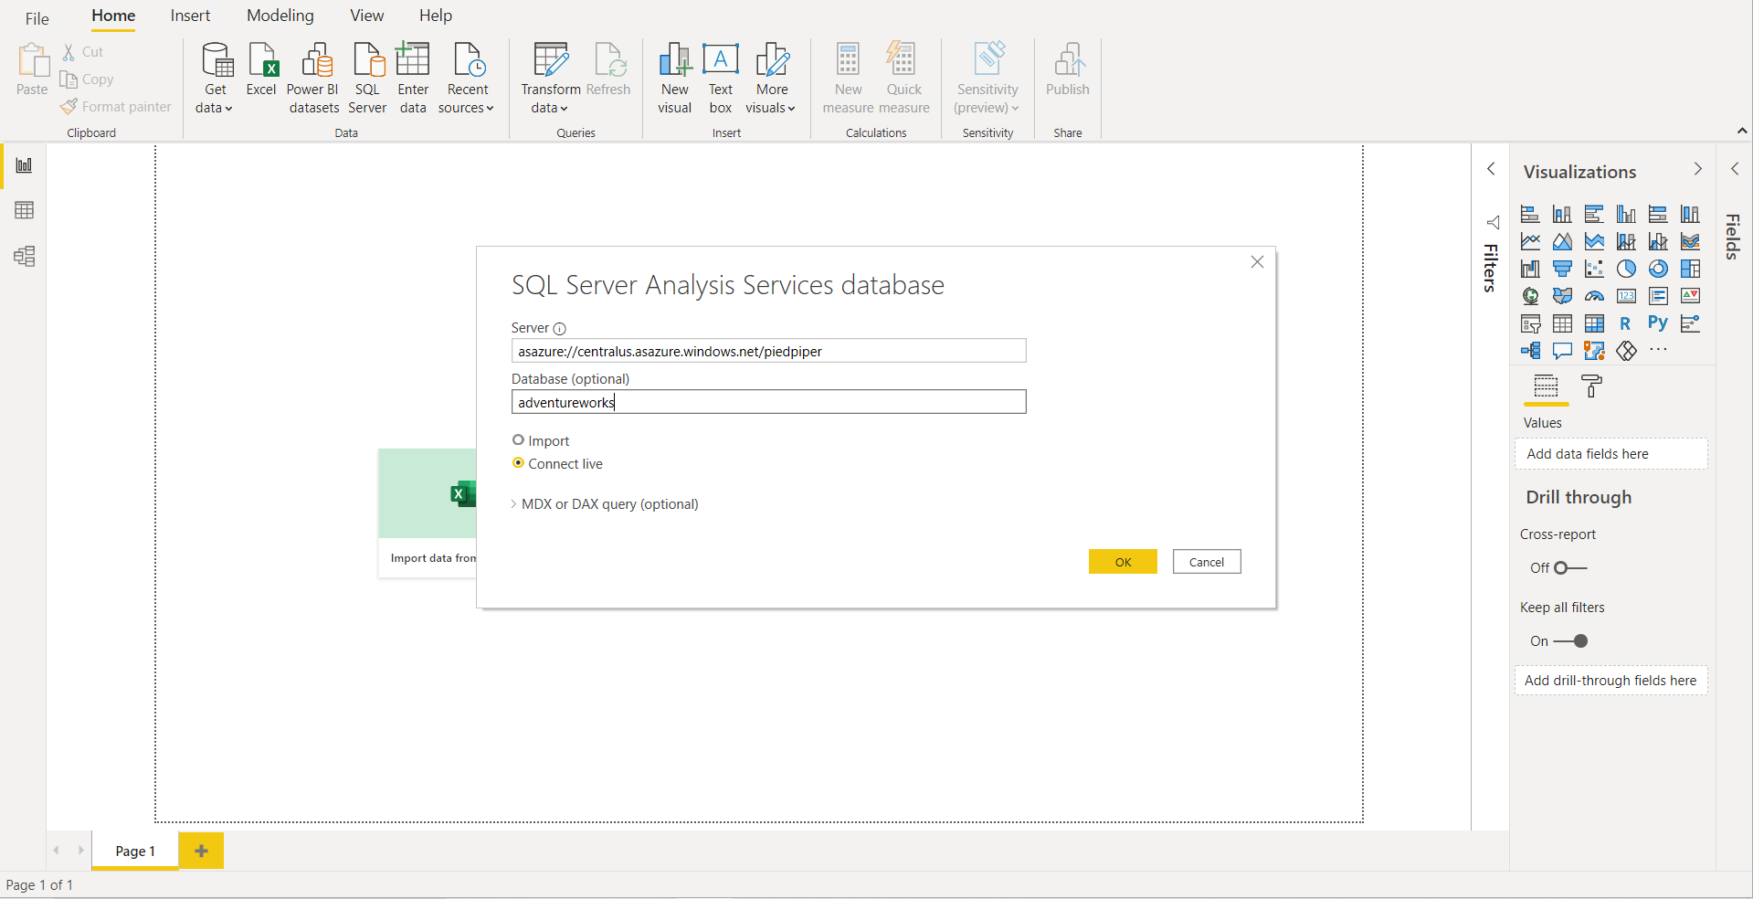

Step 6: Select **stacked column chart** in **visualizations.**

Step 7: Select **Product count** and **Category** columnsfrom the Product table in **Project** to check the **Report**.

Here we can see the graph for Product Count by its Category

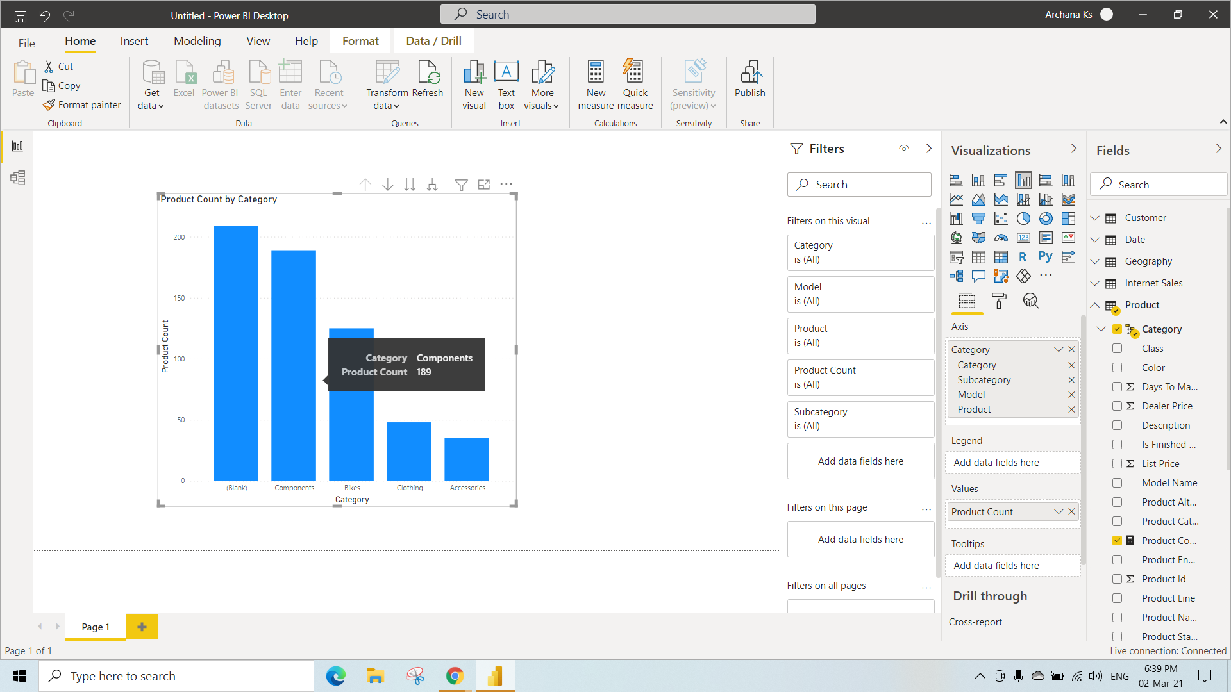

To Connect **Power BI Data Models Using Power BI:**

Step 1: go to **Get data.**

Step 2: go to **Power Platform** and select **Power BI datasets.**

Step 3: click on **Connect**.

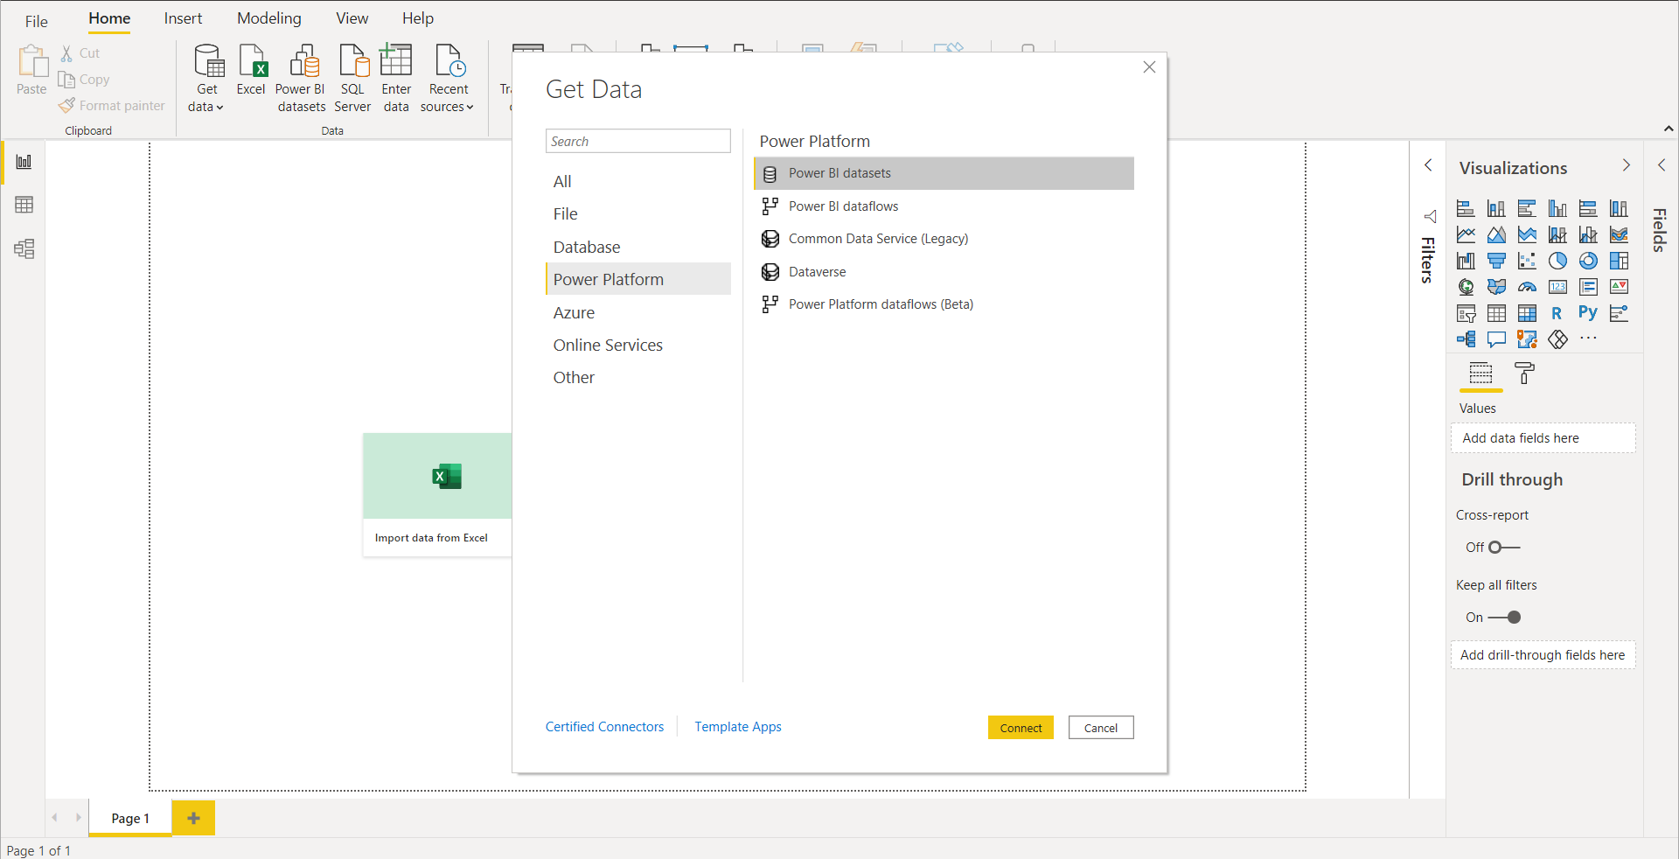

Now we can see all the Datasets.

Step 4: Select a **Dataset** to create a report.

Step 5: click on **Create.**

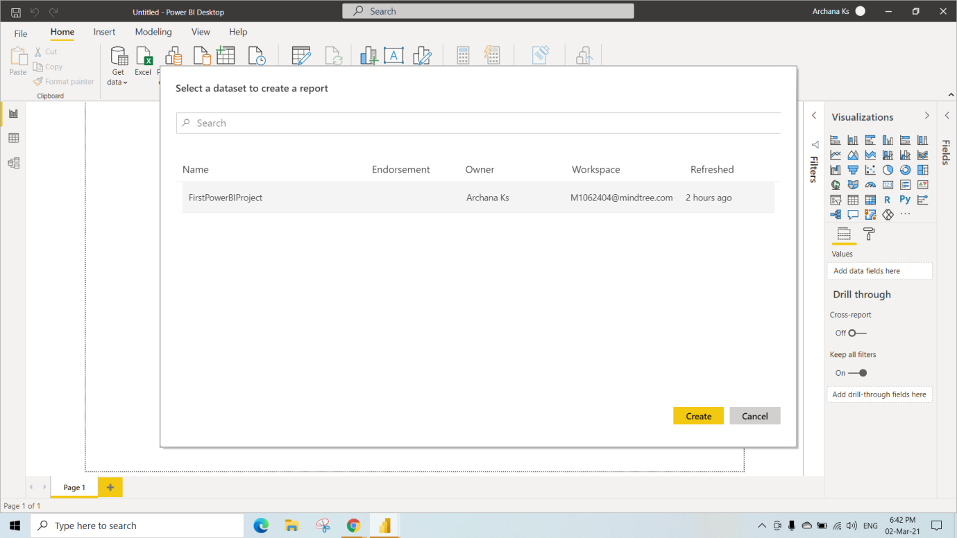

Step 8: Select **stacked column chart** in **visualizations.**

Step 9: select **Movie Count** and **Released Year** in **Movies** to check the Report.

Here we can see the Number of Movies Released in the Particular Year

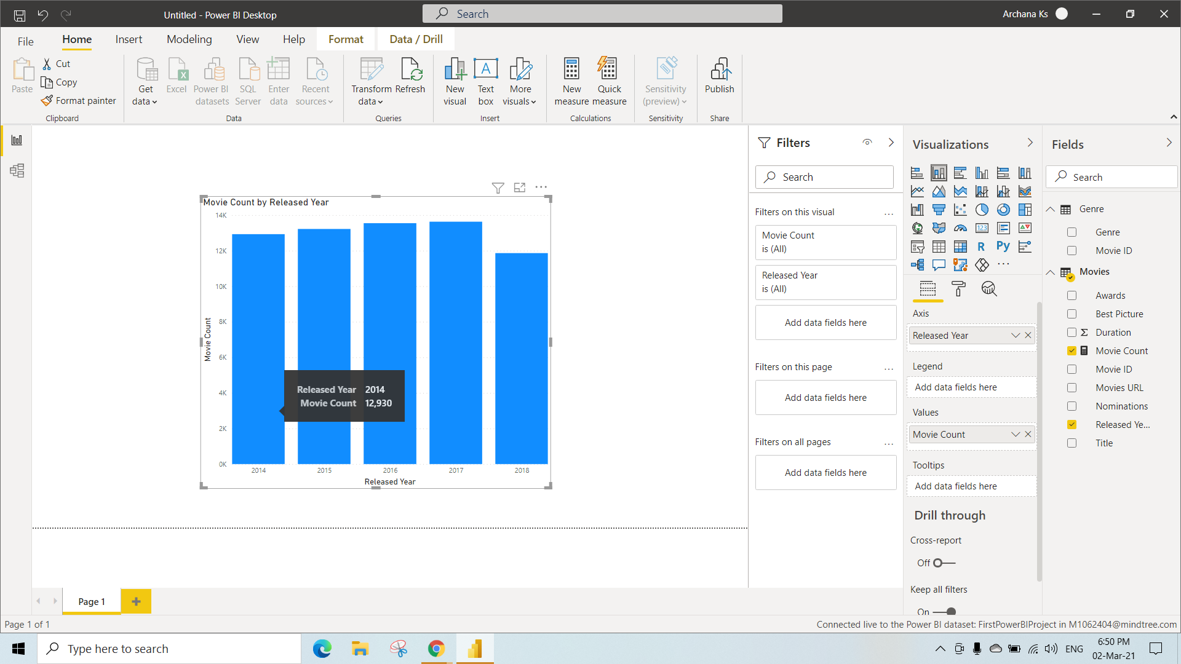

KO 2: Able to Connect to Databases through Direct Query

**Direct query:** Here you can connect Single database, there are only limited number and type of Transformations.

**Big Advantage** is Direct query comes when you are connecting to data sources where the data is changing rapidly.

Data Sources that Supports Direct Query

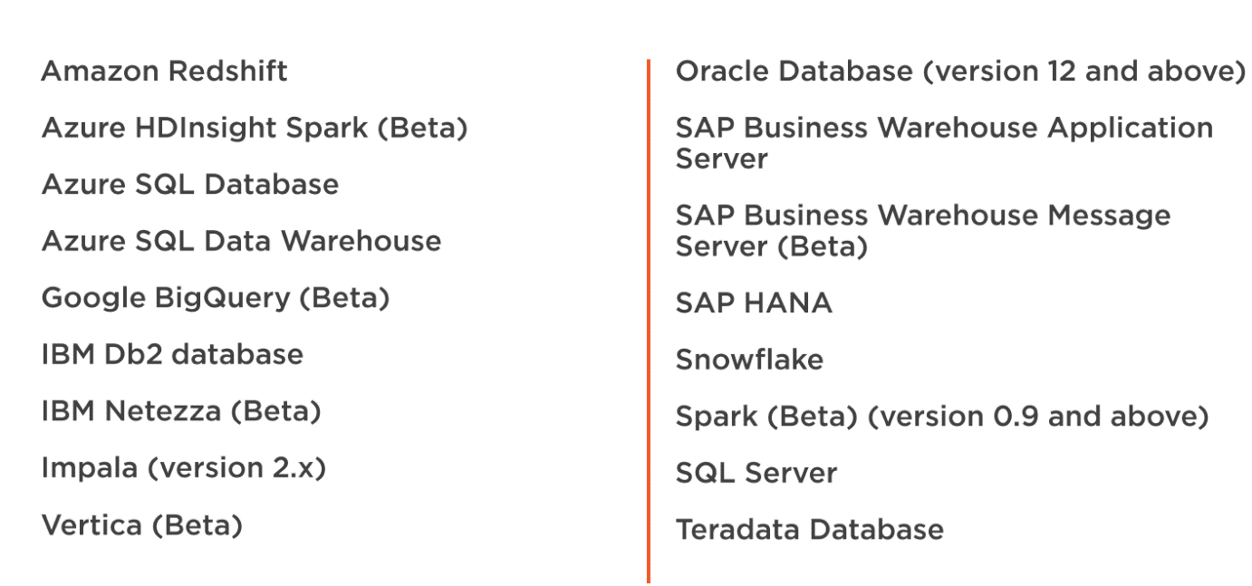

Step 1: go to **Get data.**

Step 2: go to **Azure** and select **Azure Aql Database.**

Step 3: click on **Connect**

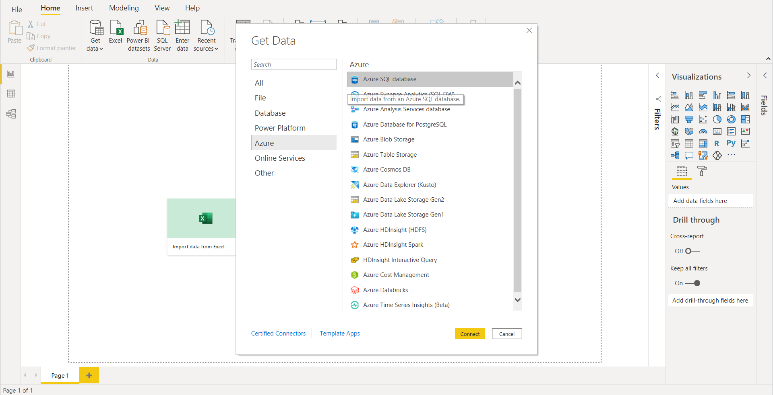

Now you will be asked to Authenticate to your database,

Step 4: Enter the **Server** and **database** name of Azure Database

Step 5: Select **Direct Query**.

Step 5: Click on **OK**.

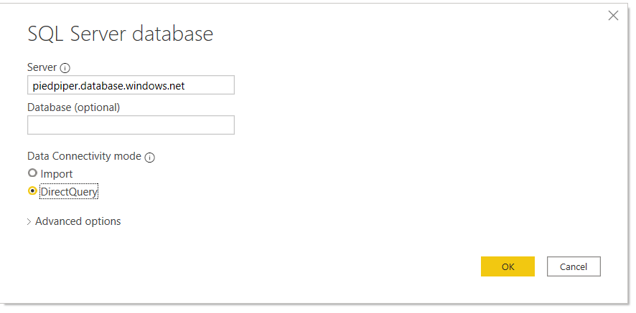

Now, we can see the Navigator page then Expand database where you can see all the Tables.

Step 6: select **Sales.T.SalesOrderDetails** and **Sales.T.SalesOrderHeader** Tables .

Step 7: Click on **Transform data** (To do modifications to the raw data).

As soon as after selecting the Transform data we will be navigated to a Query Editor Page

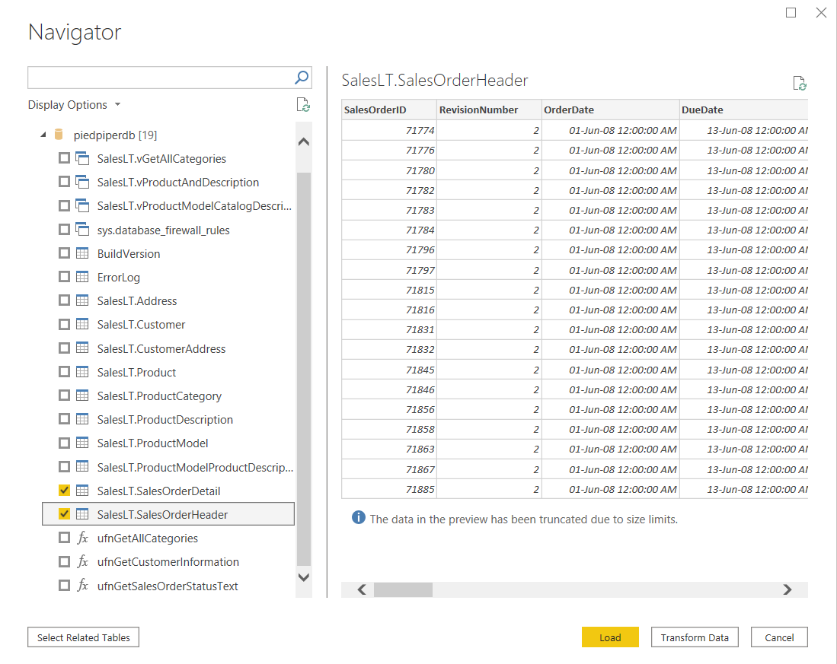

Now you can see the table with its columns.

Lets Transform the data by applying filter to the SalesOrderId.

Step 8: Select the dropdown of **SalesOrderId,** Select **number filter** in it.

we can see the new page **Filter Rows** where we can apply filter on SalesOrderID(any column).

Step 9: Select Basic, By using dropdowns we can Select any Conditions ( Here We have selected **is greater than equal to** and given the condition as **70000** (this filters the values and gives the records which are below **70000**)

Step 10: Click on **OK**

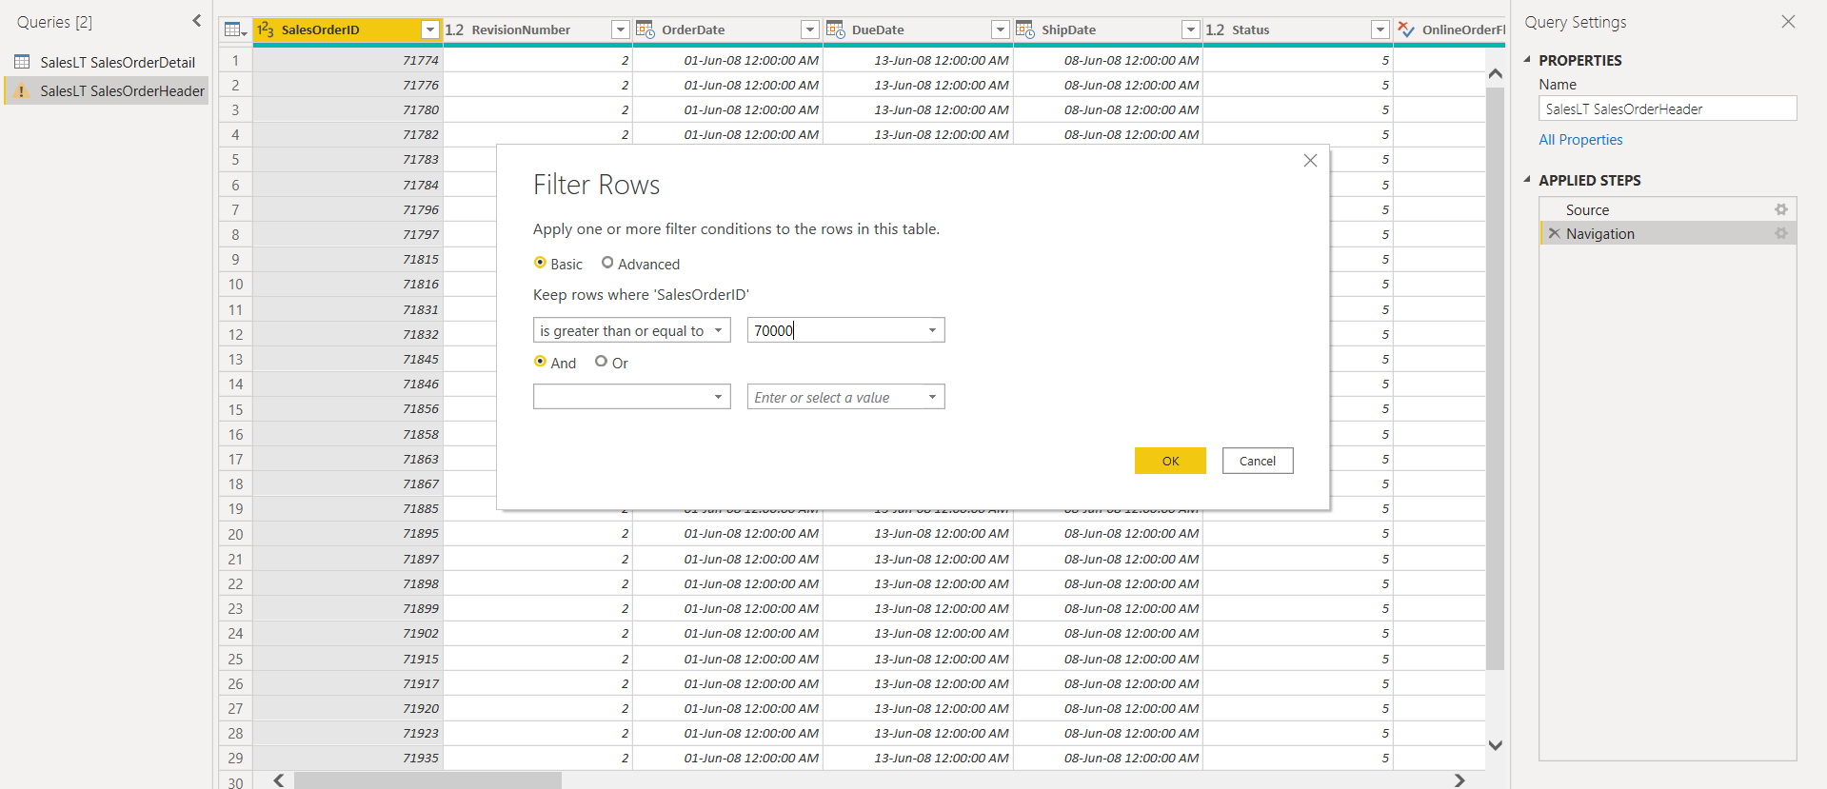

Here you can only see report and model

You cannot see Data present there.

Step 11: Select a **Table** in the **visualizations** and Select columns OrderQty, ProductId, LineTotal, SalesOrderID.

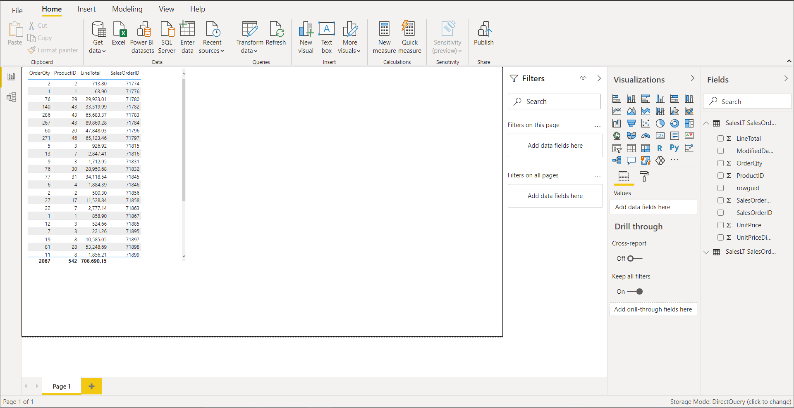

Publishing to PowerBI

Step 12: Click on Publish

While Publishing to PowerBI, We get this

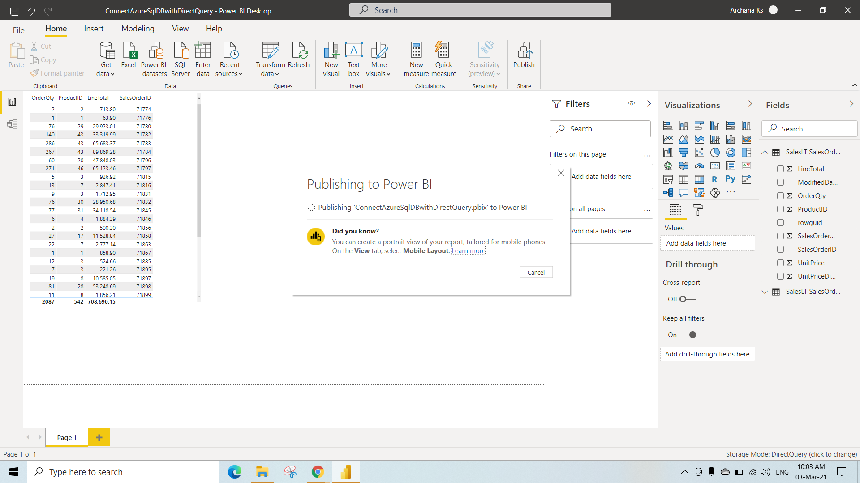

After Publision successful

Step 13: Now, Open the link ‘ConnectAzureSqlDBwithDirectQuery.pbix’ (which takes us to workspace)

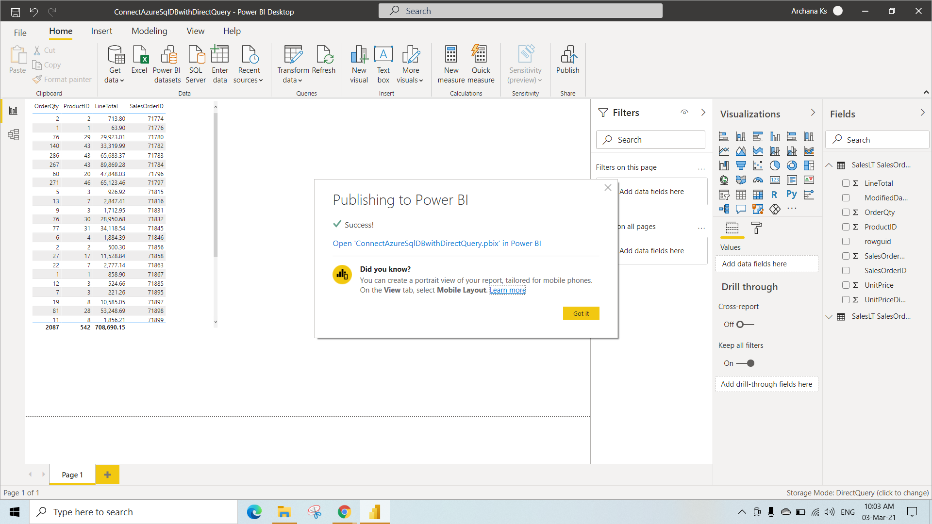

Step 14: Login to your account

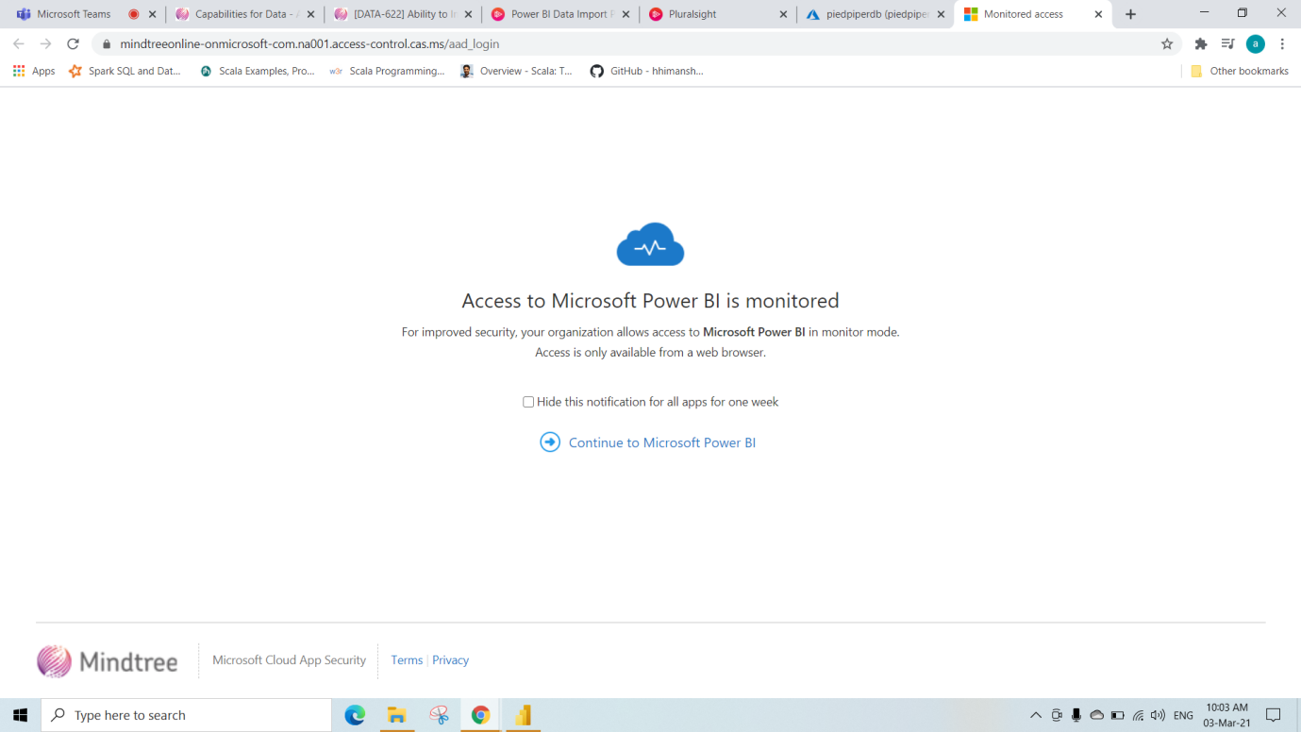

Now, you can see your workspace

Step 15:Under the Dataset Right click on **project** which we Published that is ‘ConnectAzureSqlDBwithDirectQuery’

Step 16: select **Settings**.

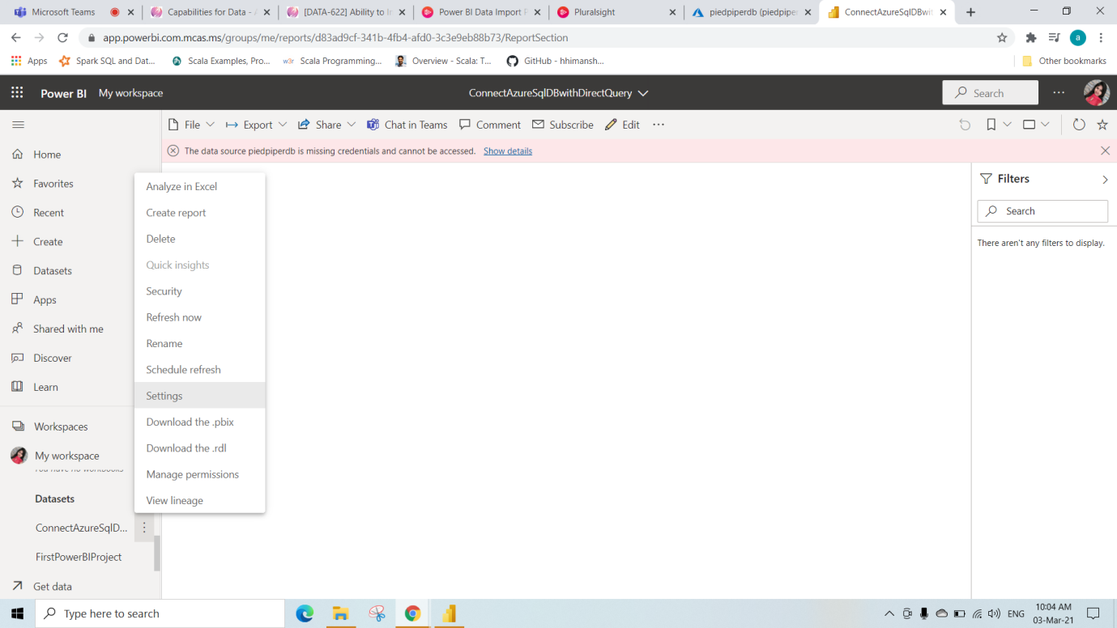

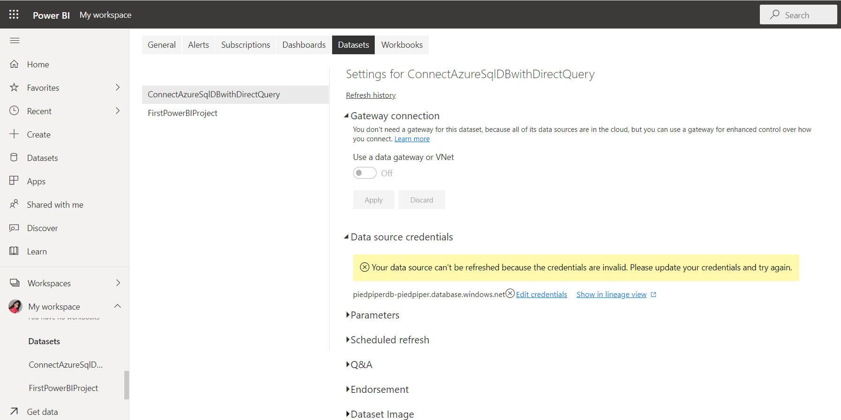

KO 3: Able to Configure Privacy Levels for Data Sources , Connect to Online Sources Using Power BI and Connect to SharePoint Data.

There are 4 Data Privacy Levels:

1. Public
2. None
3. Organizational
4. Private

In **Power BI Desktop Application**, privacy levels specify an isolation level that defines the degree that one data source will be isolated from other data sources. Although a restrictive isolation level blocks information from being exchanged between data sources, it may reduce functionality and impact performance.

General Privacy Levels Settings

The **Privacy Levels** setting, found in **File 🡪 Options and settings 🡪Options** and then **Current File 🡪 Privacy** determines whether Power BI Desktop uses your Privacy Level settings while combining data.

Step 1: Go to **File**

Step 2: Click on **Options and settings** and select **Options**

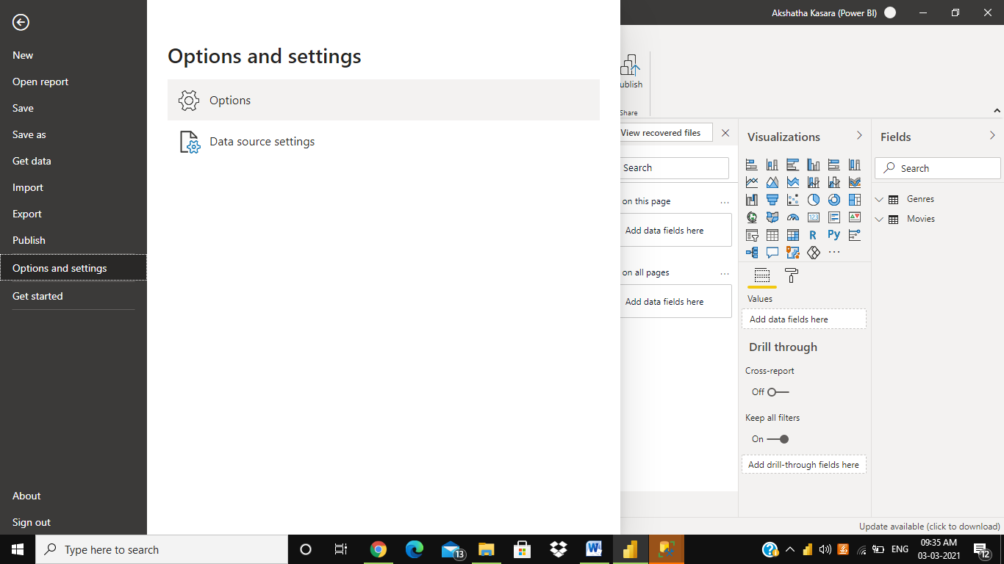

**Combine data according to your Privacy Level settings for each source** (on, and the default setting) 🡪 It means Privacy level settings are used to determine the level of isolation between data sources when combining data.

Setting privacy levels at Global level

There are Three options as shown in below Image.

Step 3: Select **combine data according to files privacy levels settings**

Click Ok

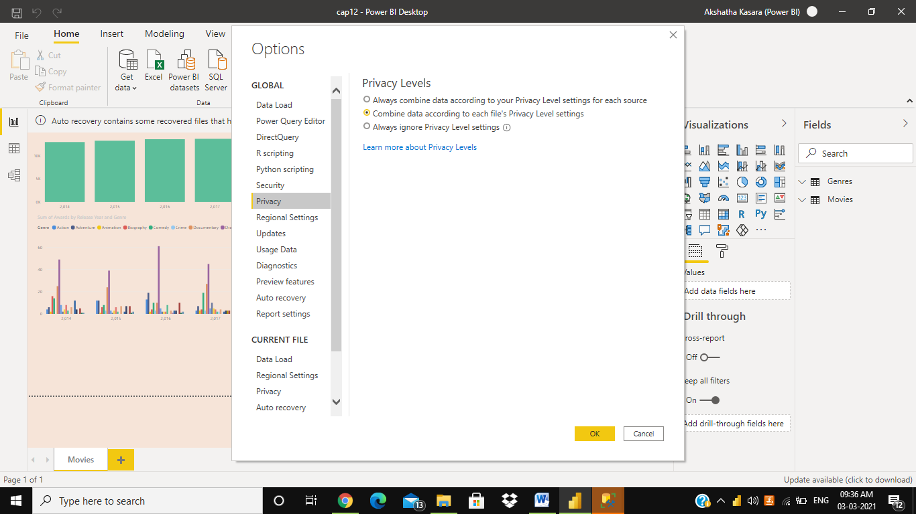

Similarly, If we want to have specific privacy levels for specific Table.

Step 4: select **privacy** in **CURRENT FILE**

Step 5: select **combine data according to files privacy levels settings for each source.**

Step 6: click **OK** and **close**

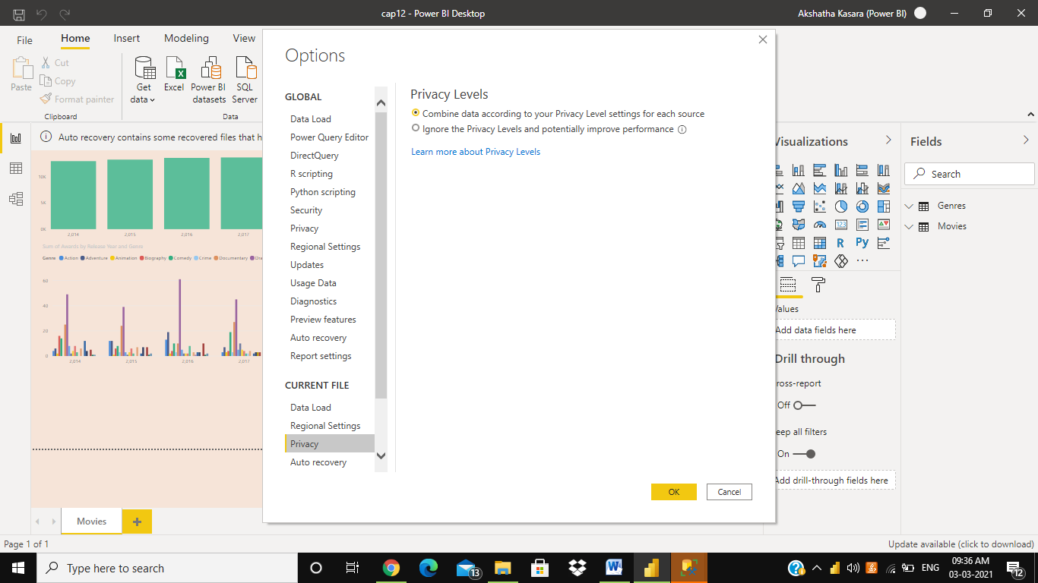

Now setting privacy levels,

Step 7: Go to **edit query.**

Step 8: Select **Data Source Settings**

Step 9: Browse your file path

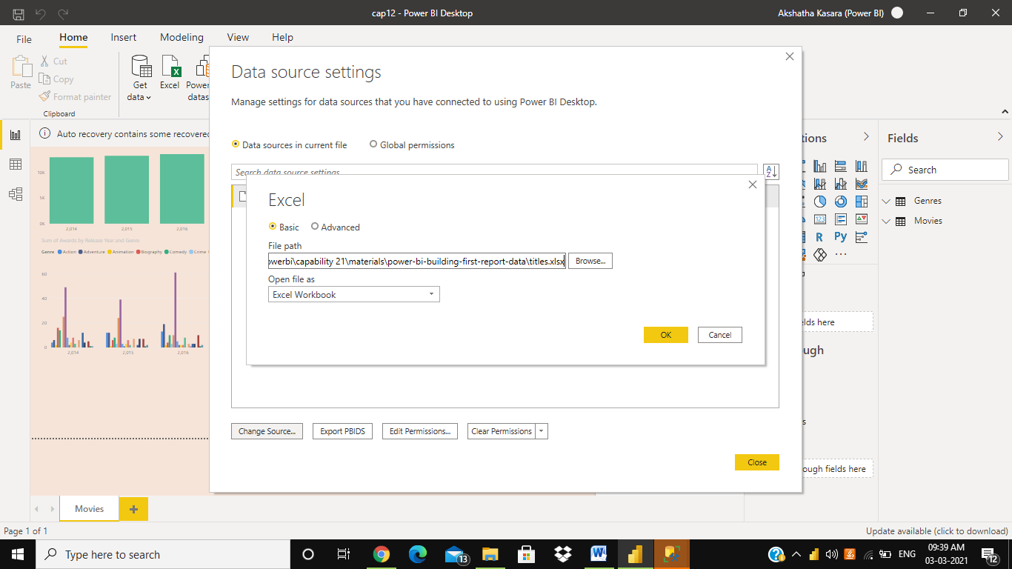

Step 10: click on **Edit Permissions**

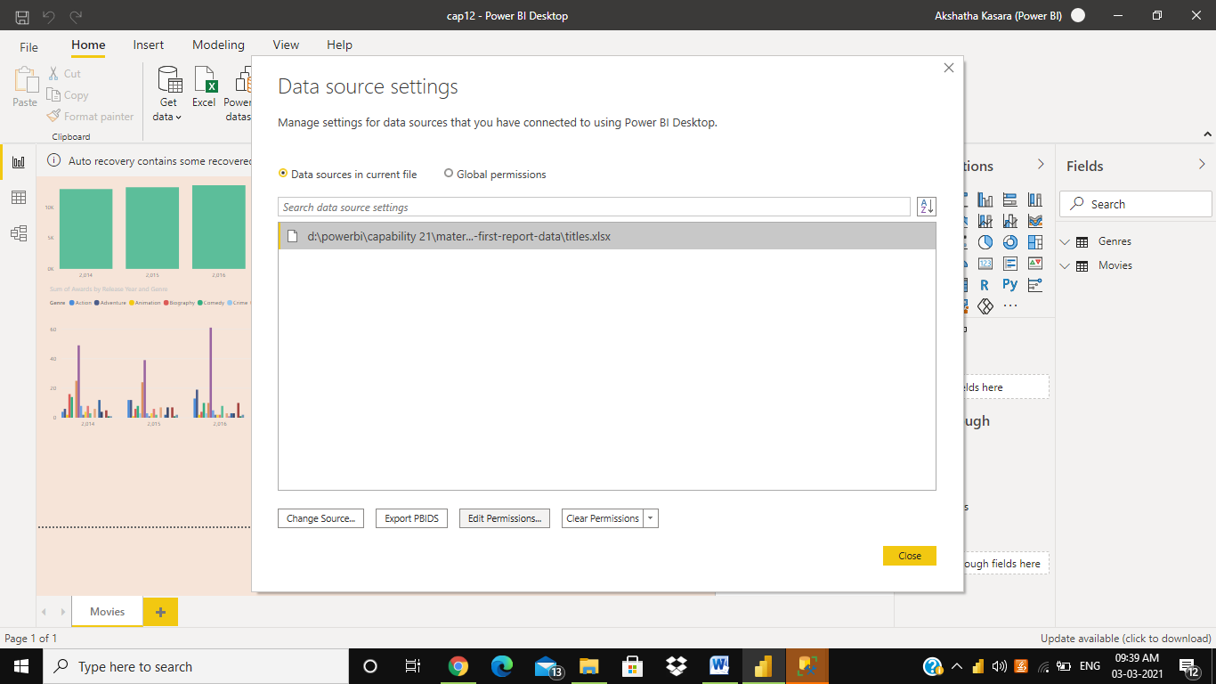

Step 11: Change it to **Public** or any Privacy Levels according to your Requirements(Here We have set privacy level as Public)

Two Tables with different Privacy Levels cannot be connected

Step 12: click on **OK** and **CLOSE**

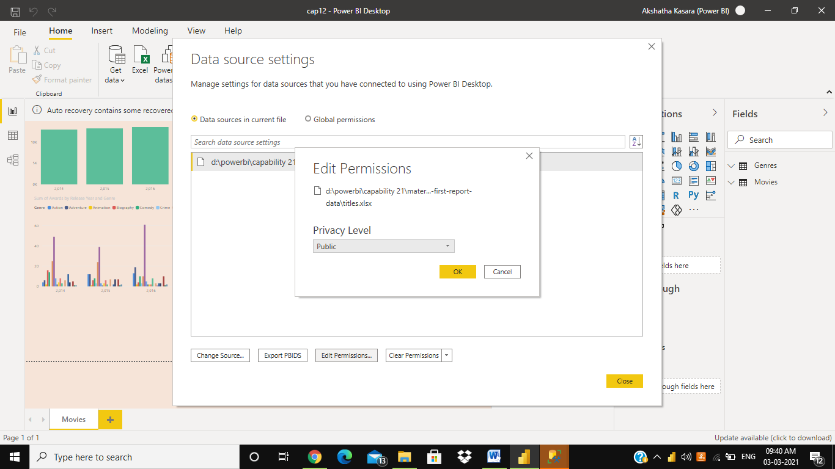

Now we are in Power Query Editor,

Now Push the data to R Program(**Run R Script**)

Step 13: Go to Transform.

Step 14: Select **Run R Script**

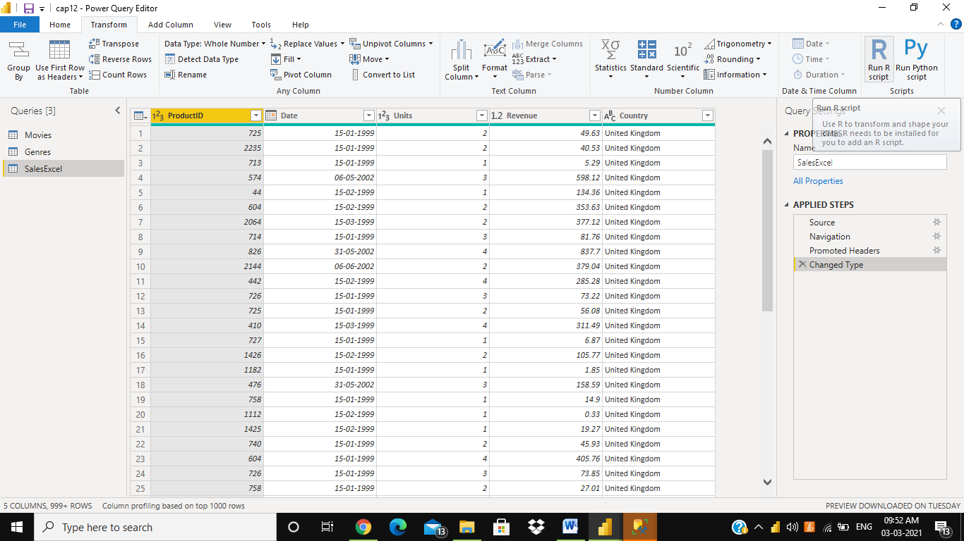

Step 15: Write a script as ,

**Output🡨head(dataset,5)**

Step 16: click on **OK**

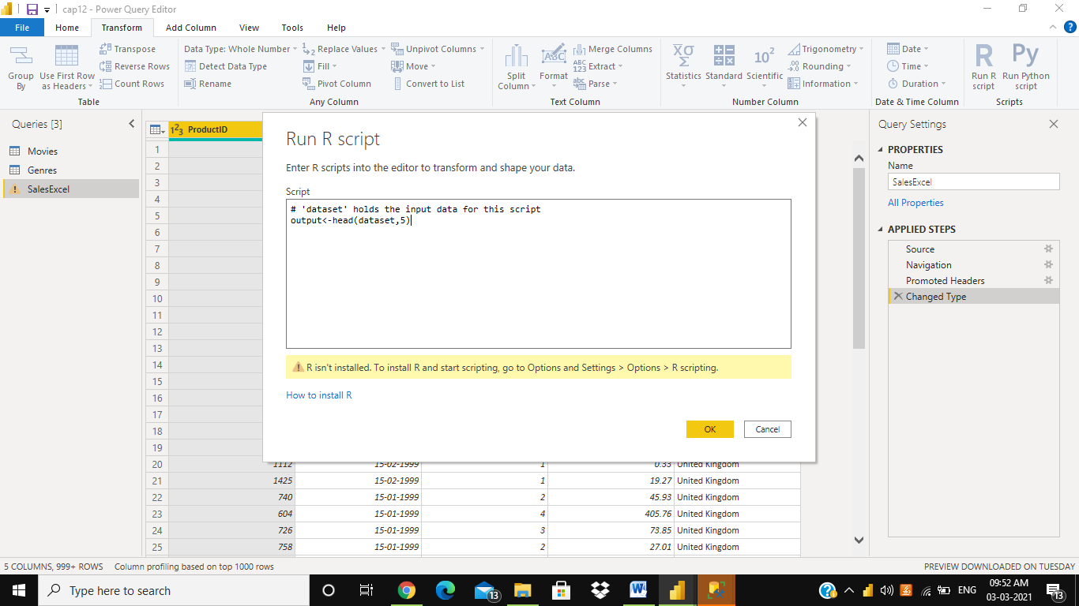

Now, Changing back the privacy settings of current file.

Step 17: Go to **File.**

Step 18: Select **options and settings** and select **options**

Step 19: select **privacy** in **current file**

Step 20: select **Ignore the Privacy level and potentially improve performance**

So that we can connect any Tables

Step 21: click on **OK**

**Ignore the Privacy levels and potentially improve performance** (off)🡪 It Means Privacy levels are not considered when combining data, however, performance and functionality of the data may increase.

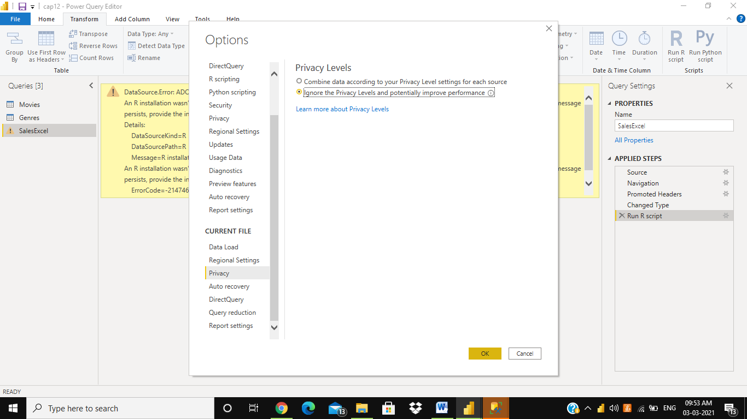

Step 21: Go to **Home.**

Step 22: Select **Data Source Settings 🡪 R 🡪 edit permissions 🡪 set it to Private 🡪 ok 🡪 Close**

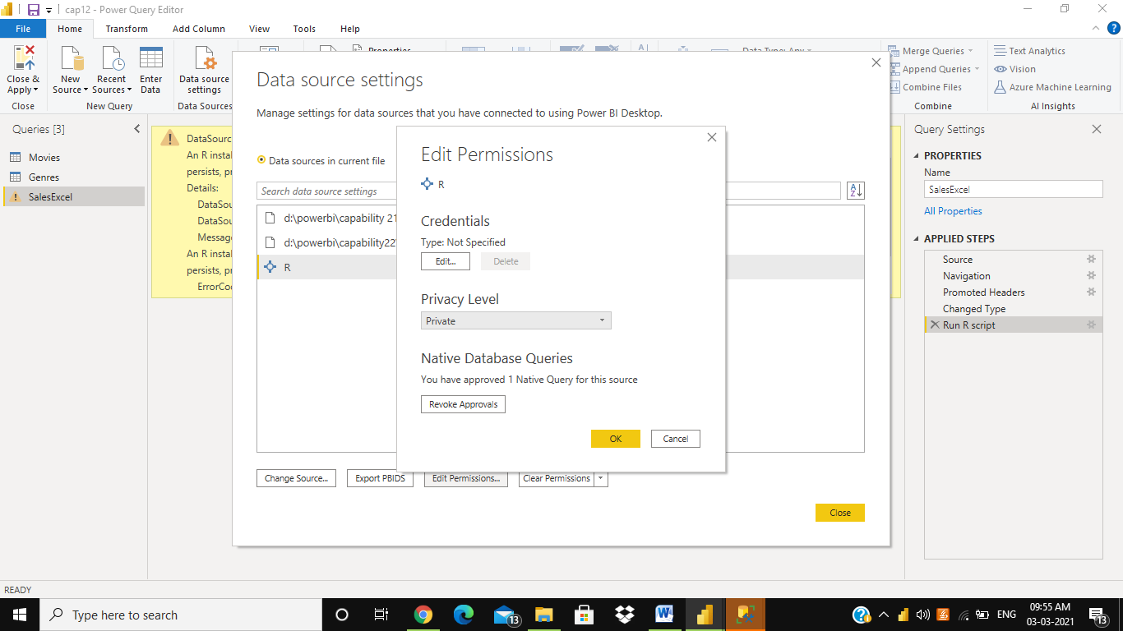

Step 24:click on **Refresh preview** under **Home**

Step 23:click on **Close and apply** under **Home**

